**HL Unit 7** **– Control**  
Test 1

1. A biotechnology company owns a resource centre which collects and classifies organisms

for use in research.

Only authorized employees are allowed access to some laboratories in the resource centre.

These laboratories are protected by locked doors. Each door is controlled by a separate microprocessor. A digital camera is used to scan the iris of an employee who wishes to

enter the lab. If the employee is authorized the doors are unlocked.

1. Identify **two** benefits of using a digital camera as an input device in this control system. [2]

1. Outline the use of a microprocessor in this control system. [2]

1. Outline the function of an output transducer. [2]

The company is planning to use a centralized computer system to secure the resource  
 centre’s building.

1. Compare a centrally controlled system with the system described above. [4]

The operating system has an important role in this system.

1. Identify **two** functions of the operating system. [2]

Polling and interrupt are two operating system management techniques.

1. Suggest with reasons which of these two techniques is the most appropriate for   
   this centrally controlled system. [3]

1. An embedded system is used to control the speed of an electric motor.
2. With reference to the example, above, define an embedded system. [2]

The diagram shows the main components in a typical negative feedback system.

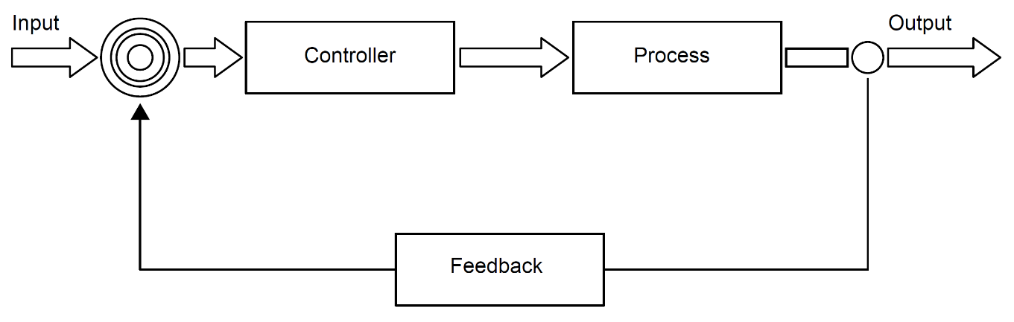

The control system for the electric motor consists of a negative feedback loop.

1. Outline the desired outcome of any feedback system. [2]

1. List the steps involved in the feedback system for the electric motor. You should make   
   use of the appropriate technical terms of the control system process. [6]

A more complex control system is used to monitor and control the functioning of a power station. This includes a dedicated operating system with sensors and output transducers (actuators) placed at various places around the power station.

1. Explain the interaction between the components identified above, if interrupts are   
   generated by the sensors. [5]

1. Discuss **one** ethical consideration of using CCTV in a workplace. [3]